Chapter 13
Project Scheduling: PERT/CPM

Learning Objectives

1. Understand the role and application of PERT/CPM for project scheduling.

2. Learn how to define a project in terms of activities such that a network can be used to describe the project.

3. Know how to compute the critical path and the project completion time.

4. Know how to convert optimistic, most probable, and pessimistic time estimates into expected activity time estimates.

5. With uncertain activity times, be able to compute the probability of the project being completed by a specific time.

6. Understand the concept and need for crashing.

7. Be able to formulate the crashing problem as a linear programming model.

8. Learn how to schedule and control project costs with PERT/Cost.

9. Understand the following terms:

network beta distribution
PERT/CPM path
activities critical path
event critical activities
optimistic time slack
most probable time crashing
pessimistic time

Solutions:

1.

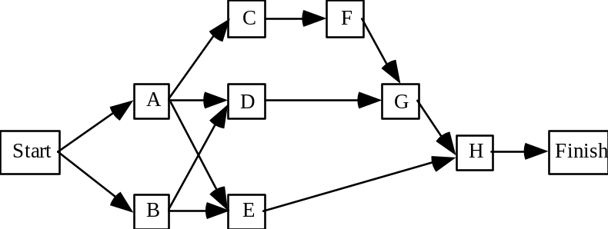

2.

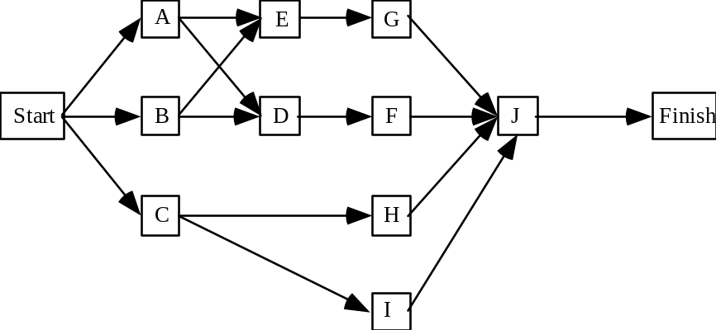

3.

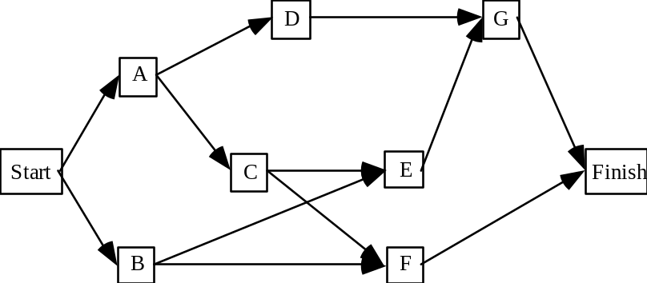

4. a.

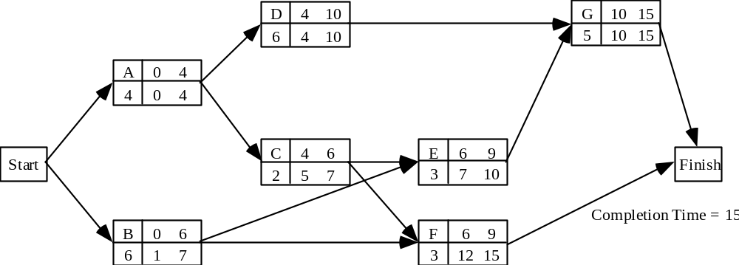

Critical Path: A-D-G

b. The critical path activities require 15 months to complete. Thus the project should be completed in 1-1/2 years.

5.
UPDATED ACTIVITY SCHEDULE FOR THE WESTERN HILLS SHOPPING CENTER PROJECT
Earliest Latest Earliest Latest
Start Start Finish Finish Slack Critical
Activity (ES) (LS) (EF) (LF) (LS – ES) Path?
A 0 0 5 5 0 Yes
B 7 11 8 12 4
C 7 8 11 12 1
D 7 7 10 10 0 Yes
E 5 5 6 6 0 Yes
F 7 7 10 10 0 Yes
G 10 10 24 24 0 Yes
H 11 12 23 24 1

6.

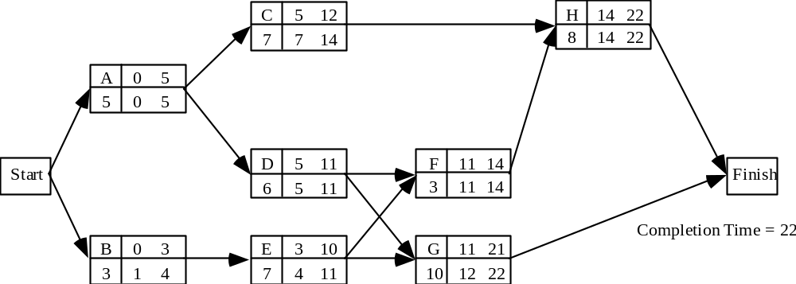

a. Critical path: A-D-F-H

b. 22 weeks
c. No, it is a critical activity

d. Yes, 2 weeks

e. Schedule for activity E:

Earliest Start 3
Latest Start 4
Earliest Finish 10
Latest Finish 11

7. a.

Start
A
B
C
D
F
E
G
H
Finish

b. A-D-E-H

c. Activity F: 4 weeks

d. Yes, project completion time is 16 weeks

Activity | Earliest  Start | Latest  Start | Earliest  Finish | Latest  Finish | Slack | Critical  Activity
A | 0 | 0 | 3 | 3 | 0 | Yes
B | 0 | 2 | 1 | 3 | 2
C | 0 | 1 | 2 | 3 | 1
D | 3 | 3 | 7 | 7 | 0 | Yes
E | 7 | 7 | 12 | 12 | 0 | Yes
F | 3 | 7 | 6 | 10 | 4
G | 7 | 10 | 13 | 16 | 3
H | 12 | 12 | 16 | 16 | 0 | Yes

8. a.

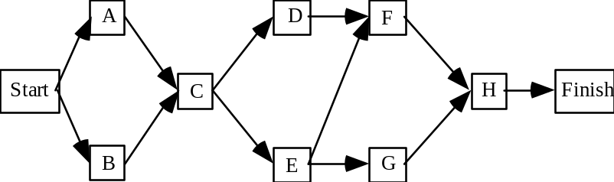

b. B-C-E-F-H

c.

Activity | Earliest  Start | Latest  Start | Earliest  Finish | Latest  Finish | Slack | Critical  Activity
A | 0 | 2 | 6 | 8 | 2
B | 0 | 0 | 8 | 8 | 0 | Yes
C | 8 | 8 | 20 | 20 | 0 | Yes
D | 20 | 22 | 24 | 26 | 2
E | 20 | 20 | 26 | 26 | 0 | Yes
F | 26 | 26 | 41 | 41 | 0 | Yes
G | 26 | 29 | 38 | 41 | 3
H | 41 | 41 | 49 | 49 | 0 | Yes

d. Yes. Project Completion Time 49 weeks.

9. a.
Start

A

B

C

D

E

F

G

Finish

b.
Activity | Expected Time | Variance
A | 10.5 | 1.36
B | 8 | 0.11
C | 6.5 | 0.69
D | 3 | 0
E | 5 | 1.78
F | 7 | 1
G | 7.5 | 1.36

Activity | ES | LS | EF | LF | Slack | Critical Activity
A | 0 | 0 | 10.5 | 10.5 | 0 | Yes
B | 0 | 9 | 8 | 17 | 9
C | 10.5 | 10.5 | 17 | 17 | 0 | Yes
D | 8 | 19.5 | 11 | 22.5 | 11.5
E | 17 | 17 | 22 | 22 | 0 | Yes
F | 11 | 22.5 | 18 | 29.5 | 11.5
G | 22 | 22 | 29.5 | 29.5 | 0 | Yes

c. The critical path A – C – E – G:

d. Expected duration = 10.5 + 6.5 + 5 + 7.5 = 29.5

Variance = 1.36 + 0.69 + 1.78 + 1.36 = 5.19

e. z = (30 – 29.5) / √5.19 = 0.219. P(Z ≤ 0.219) ≈ .5871

f. No effect on expected project duration since slack of Activity B (9 days) exceeds the delay beyond the early start time.

10. a.

Activity | Optimistic | Most  Probable | Pessimistic | Expected  Times | Variance
A | 4 | 5 | 6 | 5.00 | 0.11
B | 8 | 9 | 10 | 9.00 | 0.11
C | 7 | 7.5 | 11 | 8.00 | 0.44
D | 6 | 9 | 10 | 8.83 | 0.25
E | 6 | 7 | 9 | 7.17 | 0.25
F | 5 | 6 | 7 | 6.00 | 0.11

b. Critical activities: B-D-F

Expected project completion time: 9.00 + 8.83 + 6.00 = 23.83.

Variance of projection completion time: 0.11 + 0.25 + 0.11 = 0.47

11.

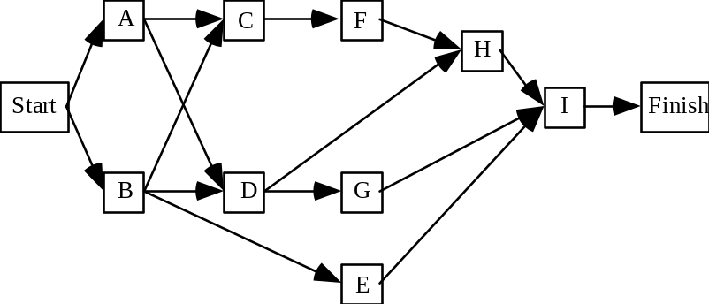

12. a.
Activity | Expected Time | Variance
A | 4.83 | 0.25
B | 4.00 | 0.44
C | 6.00 | 0.11
D | 8.83 | 0.25
E | 4.00 | 0.44
F | 2.00 | 0.11
G | 7.83 | 0.69
H | 8.00 | 0.44
I | 4.00 | 0.11

Activity | Earliest  Start | Latest  Start | Earliest  Finish | Latest  Finish | Slack | Critical  Activity
A | 0.00 | 0.00 | 4.83 | 4.83 | 0.00 | Yes
B | 0.00 | 0.83 | 4.00 | 4.83 | 0.83
C | 4.83 | 5.67 | 10.83 | 11.67 | 0.83
D | 4.83 | 4.83 | 13.67 | 13.67 | 0.00 | Yes
E | 4.00 | 17.67 | 8.00 | 21.67 | 13.67
F | 10.83 | 11.67 | 12.83 | 13.67 | 0.83
G | 13.67 | 13.83 | 21.50 | 21.67 | 0.17
H | 13.67 | 13.67 | 21.67 | 21.67 | 0.00 | Yes
I | 21.67 | 21.67 | 25.67 | 25.67 | 0.00 | Yes

Critical Path: A-D-H-I

b. E(T) = tA + tD + tH + tI
= 4.83 + 8.83 + 8 + 4 = 25.66 days

c.
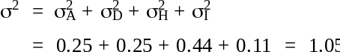

Using the normal distribution,

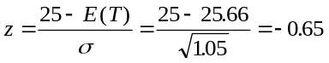
From the table for standard normal distribution, the cumulative probability for z = -0.65 is 0.2578.

Probability of 25 days or less is 0.2578.

13.
Activity | Expected Time | Variance
A | 5 | 0.11
B | 3 | 0.03
C | 7 | 0.11
D | 6 | 0.44
E | 7 | 0.44
F | 3 | 0.11
G | 10 | 0.44
H | 8 | 1.78

From problem 6, A-D-F-H is the critical path.

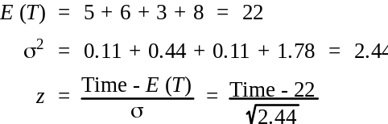

a. Time = 21 z = -0.64
Cumulative Probability = 0.2611
P(21 weeks) = 0.2611

b. Time = 22 z = 0.00
Cumulative Probability = 0.5000
P(22 weeks) = 0.5000

c. Time = 25 z = +1.92
Cumulative Probability = 0.9726
P(25 weeks) = 0.9726

14. a.
Activity | Expected Time | Variance
A | 8 | 1.78
B | 7 | 0.11
C | 12 | 4.00
D | 5 | 0.44
E | 10 | 4.00
F | 9 | 4.00
G | 15 | 2.78
H | 7 | 1.78

Activity | Earliest  Start | Latest  Start | Earliest  Finish | Latest  Finish | Slack | Critical  Activity
A | 0 | 0 | 8 | 8 | 0 | Yes
B | 8 | 14 | 15 | 21 | 6
C | 8 | 8 | 20 | 20 | 0 | Yes
D | 8 | 15 | 13 | 20 | 7
E | 20 | 20 | 30 | 30 | 0 | Yes
F | 20 | 21 | 29 | 30 | 1
G | 30 | 30 | 45 | 45 | 0 | Yes
H | 45 | 45 | 52 | 52 | 0 | Yes

Critical Path: A-C-E-G-H

b. E(T) = tA + tC + tE + tG + tH
= 8 + 12 + 10 + 15 + 7 = 52 weeks (1 year)

c. 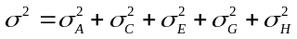
= 1.78 + 4.00 + 4.00 + 2.78 + 1.78 = 14.34

Using the normal distribution,

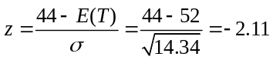

From the table for standard normal distribution, the cumulative probability for z = -2.11 is 0.0174.

Probability of 44 weeks or less is 0.0174

d. Using the normal distribution,

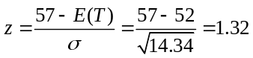

From the table for standard normal distribution, the cumulative probability for z = 1.32 is 0.9066.

Probability of more than 57 weeks = 1.0000 - 0.9066 = 0.0934

e. It is very unlikely that the project can be completed in 10 months. But it is also unlikely the project will take longer than 13 months. Therefore, Davison Construction might prefer to tell the owner that the best estimate is a completion time of one year.

15. a.

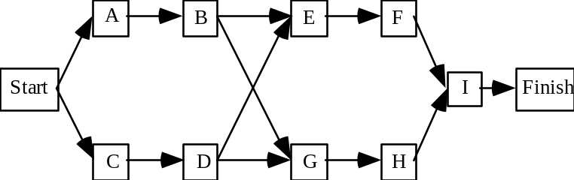

b.
Activity |  | Expected Time |  |  | Variance
A |  | 2 |  |  | 0.03
B |  | 3 |  |  | 0.44
C |  | 2 |  |  | 0.11
D |  | 2 |  |  | 0.03
E |  | 1 |  |  | 0.03
F |  | 2 |  |  | 0.11
G |  | 4 |  |  | 0.44
H |  | 4 |  |  | 0.11
I |  | 2 |  |  | 0.03
Activity | Earliest  Start |  | Latest  Start | Earliest  Finish |  | Latest  Finish | Slack |  | Critical  Activity
A | 0 |  | 0 | 2 |  | 2 | 0 |  | Yes
B | 2 |  | 2 | 5 |  | 5 | 0 |  | Yes
C | 0 |  | 1 | 2 |  | 3 | 1
D | 2 |  | 3 | 4 |  | 5 | 1
E | 5 |  | 10 | 6 |  | 11 | 5
F | 6 |  | 11 | 8 |  | 13 | 5
G | 5 |  | 5 | 9 |  | 9 | 0 |  | Yes
H | 9 |  | 9 | 13 |  | 13 | 0 |  | Yes
I | 13 |  | 13 | 15 |  | 15 | 0 |  | Yes

c. Critical Path: A-B-G-H-I

E(T) = 2 + 3 + 4 + 4 + 2 = 15 weeks

d. Variance on critical path

σ2 = 0.03 + 0.44 + 0.44 + 0.11 + 0.03 = 1.05

From the table for standard normal distribution, the cumulative probability of 0.99
occurs at z = 2.33. Thus

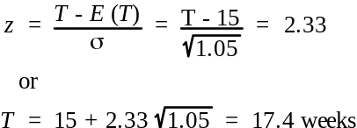

16. a. A-D-G-J

E(T) = 6 + 5 + 3 + 2 = 16
σ2 = 1.78 + 1.78 + 0.25 + 0.11 = 3.92

A-C-F-J

E(T) = 6 + 3 + 2 + 2 = 13
σ2 = 1.78 + 0.11 + 0.03 + 0.11 = 2.03

B-H-I-J

E(T) = 2 + 4 + 2 + 2 = 10
σ2 = 0.44 + 0.69 + 0.03 + 0.11 = 1.27

b. A-D-G-J

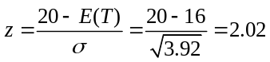 Cumulative probability = 0.9783

A-C-F-J

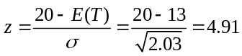 Cumulative probability is approximately 1.0000

B-H-I-J

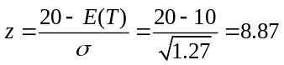 Cumulative probability is approximately 1.0000

c. Critical path is the longest path and generally will have the lowest probability of being completed by the desired time. The noncritical paths should have a higher probability of being completed on time.

It may be desirable to consider the probability calculation for a noncritical path if the path activities have little slack, if the path completion time is almost equal to the critical path completion time, or if the path activity times have relatively high variances. When all of these situations occur, the noncritical path may have a probability of completion on time that is less than the critical path.

17. a.

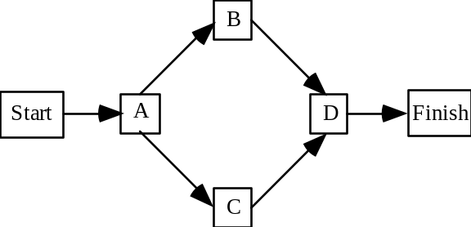

b. Critical Path A-B-D
Expected Time = 4.5 + 8.0 + 6.0 = 18.5 weeks
c. Material Cost = $3000 + $5000 = $8000

Best Cost (Optimistic Times) 3 + 5 + 2 + 4 = 14 days
Total Cost = $8000 + 14($400) = $12,800

Worst Case (Pessimistic Times) 8 + 11 + 6 + 12 = 37 days
Total Cost = $8000 + 37($400) = $22,800

d. Bid Cost = $8000 + 18.5($400) = $15,400
.50 probability time and cost will exceed the expected time and cost.

e. 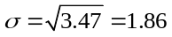

Bid = $16,800 = $8,000 + Days ($400)
400 Days = 16,800 - 8000 = 8,800
Days = 22

The project must be completed in 22 days or less.

The probability of a loss = P (T > 22)
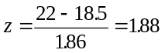
From the table for standard normal distribution, the cumulative probability for z = 1.88 is 0.9699.

Probability of 22 weeks or less is 0.9699

The probability of a loss is 1.0000 - 0.9699 = 0.0301

18. a.

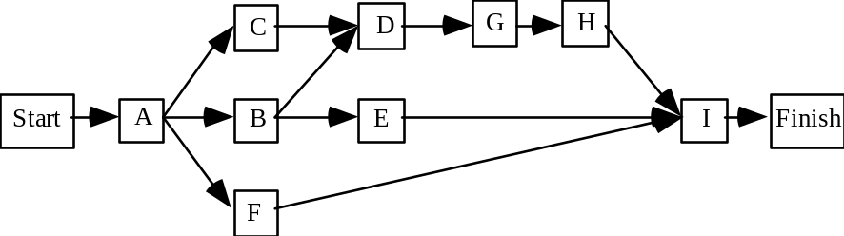

b.
Activity | Expected Time | Variance
A | 1.17 | 0.03
B | 6.00 | 0.44
C | 4.00 | 0.44
D | 2.00 | 0.11
E | 3.00 | 0.11
F | 2.00 | 0.11
G | 2.00 | 0.11
H | 2.00 | 0.11
I | 1.00 | 0.00

Activity | Earliest  Start | Latest  Start | Earliest  Finish | Latest  Finish | Slack | Critical  Activity
A | 0.00 | 0.00 | 1.17 | 1.17 | 0.00 | Yes
B | 1.17 | 1.17 | 7.17 | 7.17 | 0.00 | Yes
C | 1.17 | 3.17 | 5.17 | 7.17 | 2.00
D | 7.17 | 7.17 | 9.17 | 9.17 | 0.00 | Yes
E | 7.17 | 10.17 | 10.17 | 13.17 | 3.00
F | 1.17 | 11.17 | 3.17 | 13.17 | 10.00
G | 9.17 | 9.17 | 11.17 | 11.17 | 0.00 | Yes
H | 11.17 | 11.17 | 13.17 | 13.17 | 0.00 | Yes
I | 13.17 | 13.17 | 14.17 | 14.17 | 0.00 | Yes

c. Critical Path: A-B-D-G-H-I
Expected Project Completion Time = 1.17 + 6 + 2 + 2 + 2 + 1 = 14.17 weeks

d. Compute the probability of project completion in 13 weeks or less.

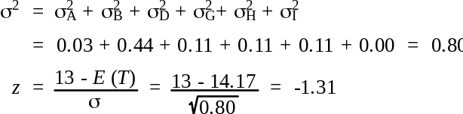

From the table for standard normal distribution, the cumulative probability for z = -1.31 is 0.0951.

Probability of 13 weeks or less is 0.0951

With this low probability, the manager should start prior to February 1.

19. a.

Activity | Expected Time | Variance
A | 4 | 0.11
B | 4 | 0.44
C | 5 | 0.11
D | 3 | 0.11
E | 10 | 1.78
F | 9 | 0.69
G | 6 | 0.25
H | 7 | 1.78
I | 3 | 0.44
J | 5 | 0.11

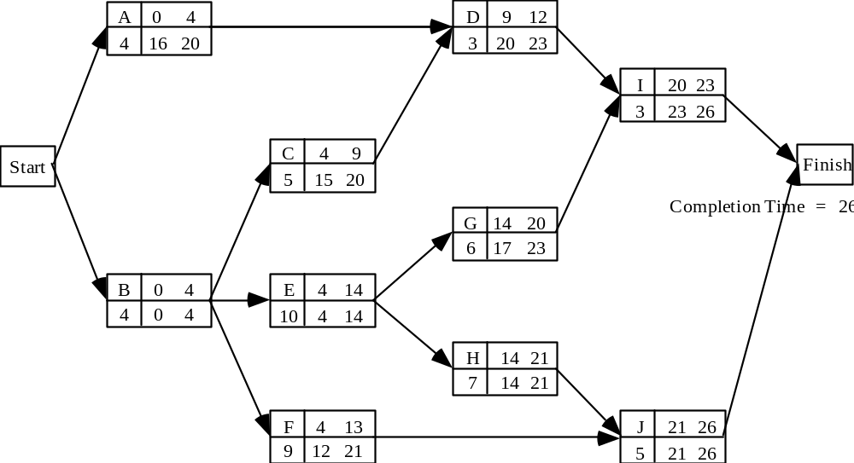

Activity | Earliest  Start | Latest  Start | Earliest  Finish | Latest  Finish | Slack | Critical  Activity
A | 0 | 16 | 4 | 20 | 16
B | 0 | 0 | 4 | 4 | 0 | Yes
C | 4 | 15 | 9 | 20 | 11
D | 9 | 20 | 12 | 23 | 11
E | 4 | 4 | 14 | 14 | 0 | Yes
F | 4 | 12 | 13 | 21 | 8
G | 14 | 17 | 20 | 23 | 3
H | 14 | 14 | 21 | 21 | 0 | Yes
I | 20 | 23 | 23 | 26 | 3
J | 21 | 21 | 26 | 26 | 0 | Yes

Critical Path: B-E-H-J

b. E(T) = tB + tE + tH + tJ
= 4 + 10 + 7 + 5 = 26

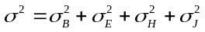
= 0.44 + 1.78 + 1.78 + 0.11 = 4.11

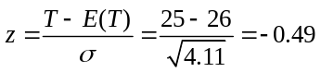 Cumulative Probability P(25 weeks) = 0.3121

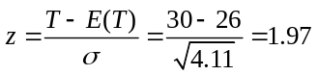 Cumulative Probability P(30 weeks) = 0.9756

20. a.
Activity | Maximum  Crash | Crash  Cost/Week
A | 2 | 400
B | 3 | 667
C | 1 | 500
D | 2 | 300
E | 1 | 350
F | 2 | 450
G | 5 | 360
H | 1 | 1000

Min | 400Y_{A} | + | 667Y_{B} | + | 500Y_{C} | + | 300Y_{D} | + | 350Y_{E} | + | 450Y_{F} | + | 360Y_{G} | + | 1000Y_{H}
s.t.

x_{A} + y_{A} ≥ 3 | x_{E} + y_{E} - x_{D} ≥ 4 | x_{H} + y_{H} - x_{G} | ≥ 3
x_{B} + y_{B} ≥ 6 | x_{F} + y_{F} - x_{E} ≥ 3 | x_{H} | ≤ 16
x_{C} + y_{C} - x_{A} ≥ 2 | x_{G} + y_{G} - x_{C} ≥ 9
x_{D} + y_{D} - x_{C} ≥ 5 | x_{G} + y_{G} - x_{B} ≥ 9
x_{D} + y_{D} - x_{B} ≥ 5 | x_{H} + y_{H} - x_{F} ≥ 3

Maximum Crashing:
y_{A} ≤ 2
y_{B} ≤ 3
y_{C} ≤ 1
y_{D} ≤ 2
y_{E} ≤ 1
y_{F} ≤ 2
y_{G} ≤ 5
y_{H} ≤ 1

b. Linear Programming Solution

Activity | Crash Time | New Time | Crash Cost
A | 0 | 3 | —
B | 1 | 5 | 667
C | 0 | 2 | —
D | 2 | 3 | 600
E | 1 | 3 | 350
F | 1 | 2 | 450
G | 1 | 8 | 360
H | 0 | 3 | —
 |  | Total Crashing Cost | $2,427

c.

Activity | Earliest  Start | Latest  Start | Earliest  Finish | Latest  Finish | Slack | Critical  Activity
A | 0 | 0 | 3 | 3 | 0 | Yes
B | 0 | 0 | 5 | 5 | 0 | Yes
C | 3 | 3 | 5 | 5 | 0 | Yes
D | 5 | 5 | 8 | 8 | 0 | Yes
E | 8 | 8 | 11 | 11 | 0 | Yes
F | 11 | 11 | 13 | 13 | 0 | Yes
G | 5 | 5 | 13 | 13 | 0 | Yes
H | 13 | 13 | 16 | 16 | 0 | Yes

All activities are critical.

21. a.

Activity | Earliest  Start | Latest  Start | Earliest  Finish | Latest  Finish | Slack | Critical  Activity
A | 0 | 0 | 3 | 3 | 0 | Yes
B | 0 | 1 | 2 | 3 | 1
C | 3 | 3 | 8 | 8 | 0 | Yes
D | 2 | 3 | 7 | 8 | 1
E | 8 | 8 | 14 | 14 | 0 | Yes
F | 8 | 10 | 10 | 12 | 2
G | 10 | 12 | 12 | 14 | 2

Critical Path: A-C-E

Project Completion Time = tA + tC + tE = 3 + 5 + 6 = 14 days

b. Total Cost = $8,400

22. a.

Activity | Max Crash Days | Crash  Cost/Day
A | 1 | 600
B | 1 | 700
C | 2 | 400
D | 2 | 400
E | 2 | 500
F | 1 | 400
G | 1 | 500

Min | 600y_{A} | + | 700y_{B} | + | 400y_{C} | + | 400y_{D} | + | 500y_{E} | + | 400y_{F} | + | 400y_{G}
s.t.

x_{A} + y_{A} ≥ 3
x_{B} + y_{B} ≥ 2
x_{C} + y_{C} - x_{A} ≥ 5
x_{D} + y_{D} - x_{B} ≥ 5
x_{E} + y_{E} - x_{C} ≥ 6
x_{E} + y_{E} - x_{D} ≥ 6
x_{F} + y_{F} - x_{C} ≥ 2
x_{F} + y_{F} - x_{D} ≥ 2
x_{G} + y_{G} - x_{F} ≥ 2
xFIN - x_{E} ≥ 0
xFIN - x_{G} ≥ 0
xFIN ≤ 12
y_{A} ≤ 1
y_{B} ≤ 1
y_{C} ≤ 2
y_{D} ≤ 2
y_{E} ≤ 2
y_{F} ≤ 1
y_{G} ≤ 1
All x, y ≥ 0

b.
Activity | Crash | Crashing Cost
C | 1 day | $400
E | 1 day | 500
 | Total | $900

c. Total Cost = Normal Cost + Crashing Cost
= $8,400 + $900 = $9,300

23. a. This problem involves the formulation of a linear programming model that will determine the length of the critical path in the network. Since xI, the completion time of activity I, is the project completion time, the objective function is:

Min xI

Constraints are needed for the completion times for all activities in the project. The optimal solution will determine xI which is the length of the critical path.

Activity
A | xA ≥ τA
B | xB ≥ τB
C | xC - xA ≥ τC
D | xD - xA ≥ τD
E | xE - xA ≥ τE
F | xF - xE ≥ τF
G | xG - xD ≥ τG
 | xG - xF ≥ τG
H | xH - xB ≥ τH
 | xH - xC ≥ τH
I | xI - xG ≥ τI
 | xI - xH ≥ τI
All x ≥ 0

24. a.

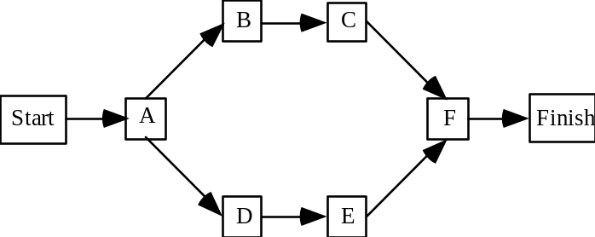

b.

Activity | Earliest  Start | Latest  Start | Earliest  Finish | Latest  Finish | Slack
A | 0 | 0 | 10 | 10 | 0
B | 10 | 10 | 18 | 18 | 0
C | 18 | 18 | 28 | 28 | 0
D | 10 | 11 | 17 | 18 | 1
E | 17 | 18 | 27 | 28 | 1
F | 28 | 28 | 31 | 31 | 0
c. Activities A, B, C, and F are critical. The expected project completion time is 31 weeks.

d.

Crash Activities | Number of Weeks | Cost
A | 2 | $ 40
B | 2 | 30
C | 1 | 20
D | 1 | 10
E | 1 | 12.5
 |  | $ 112.5

e.
Activity | Earliest  Start | Latest  Start | Earliest  Finish | Latest  Finish | Slack
A | 0 | 0 | 8 | 8 | 0
B | 8 | 8 | 14 | 14 | 0
C | 14 | 14 | 23 | 23 | 0
D | 8 | 8 | 14 | 14 | 0
E | 14 | 14 | 23 | 23 | 0
F | 23 | 23 | 26 | 26 | 0

All activities are critical.

f. Total added cost due to crashing $112,500 (see part d.)

25. a.
Let | Ki | = | Cost to crash activity i one week
 | Mi | = | Maximum crash time in weeks for activity i
 | Yi | = | Number of weeks activity i is crashed
 | Xi | = | Completion time for activity i
 | Ti | = | Normal completion time for activity i

Min | K_{A}y_{A} | + | K_{B}y_{B} | + | K_{C}y_{C} | + | K_{D}y_{D} | + | K_{E}y_{E} |  | + |  | K_{F}y_{F} |  | + |  | K_{G}y_{G} |  | + |  | K_{H}y_{H} |  | + |  | K_{I}y_{I} |  | + |  | K_{J}y_{J}
s.t.
x_{A} + y_{A} ≥ τ_{A}
x_{B} + y_{B} ≥ τ_{B}
x_{C} + y_{C} - x_{B} ≥ τ_{C}
x_{D} + y_{D} - x_{A} ≥ τ_{D}
x_{D} + y_{D} - x_{C} ≥ τ_{D}
x_{E} + y_{E} - x_{B} ≥ τ_{E}
x_{F} + y_{F} - x_{B} ≥ τ_{F}
x_{G} + y_{G} - x_{E} ≥ τ_{G}
x_{H} + y_{H} - x_{E} ≥ τ_{H}
x_{I} + y_{I} - x_{D} ≥ τ_{I}
x_{I} + y_{I} - x_{G} ≥ τ_{I}
x_{J} + y_{J} - x_{F} ≥ τ_{J}
x_{J} + y_{J} - x_{H} ≥ τ_{J}
xFIN - xI ≥ 0
xFIN - x_{J} ≥ 0
xFIN ≥ T

τ_{J} values can be computed from data given in problem 19. (See solution to problem 19.)

y_{A} ≤ M_{A} | y_{F} ≤ M_{F}
y_{B} ≤ M_{B} | y_{G} ≤ M_{G}
y_{C} ≤ M_{C} | y_{H} ≤ M_{H}
y_{D} ≤ M_{D} | y_{I} ≤ M_{I}
y_{E} ≤ M_{E} | y_{J} ≤ M_{J}

b. Information needed:

1. Maximum crash time for each activity (Mi)
2. Crashing cost for each activity (Ki)
3. Desired project completion time (T)

